Electronics Overview

Functional Decomp to Circuit Level

# Functional Decomp 0:

The electronics system decomposition begins at the global inputs and outputs.

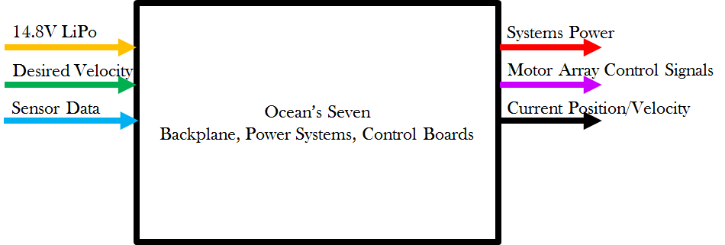

## Inputs

### Batteries

Our inputs are two 4S, 10Ah, 10C batteries, capable of supplying 200 amps of continuous draw at 14.8V. To calculate continuous current draw of a Lithium Polymer (LiPo) Battery multiply the amp-hour by the current or C rating (10C*10Ah = 100 A). To calculate the nominal battery voltage multiply the cell count or S value by 3.7V (4S*3.7V = 14.8V). Note the max and min value of the batteries should be 13.2V-16.8V. This means the minimum value for anyone cell should be 3.3V and the maximum value should be 4.2. The RoboSub Team recommends maintaining batteries above 14.8V in most cases for safety reasons.

### Sensors

There are many sensors onboard the autonomous underwater vehicle. The main sensors are Inertial Measurement Units (IMU’s) of which the robosub team has 3. They provide feedback for linear acceleration, angular velocities, and magnetometer based compass data. The RoboSub Team recommends ignoring magnetometer data due to extreme cases of magnetic interference from motors and Transdec (last measured in 2012: up to a Tesla of magnetic interference). Most IMU’s come with onboard sensor fusion that provides heading as well. The datasheets to our IMU’s are listed here, for additional documentation see the software sensors description sheets: [IMU Data Sheet Folder](https://drive.google.com/open?id=0B2LqG3aCVS5iS3FScFJTaTRZMTA).

In addition to our IMU’s we also get sensor data from a Doppler Velocity Logger or DVL. The DVL provides the velocity of the vehicle in X, Y, and Z. In addition it can also provide an exact depth of the vehicle. This sensor is incredibly accurate and allows the team to detects its position to within a few centimeters over a 30 minute run.The datasheets to the DVL is listed here, for additional documentation see the software sensors description: [DVL Data Sheet Folder](https://drive.google.com/open?id=0B2LqG3aCVS5iR01lWkx5TnZnUW8).

There are additional sensors not listed above including pressure sensors, and cameras. For information please see the software sensor description document.

## Outputs

The main outputs of the electronics system are the power outputs at 5V, 12V, 19V, and 48V. Each of these circuits will be detailed later on in the document. In addition there are current sense outputs that monitor our main system.

## Errata and Changes

Note the system has changed since the creation of the initial functional decomposition. Most notably the control system has been dropped from the system. Thus the “Desired Velocity” and “Motor Array Controls Signals” have been dropped from the main system description.

In addition no 3.3V rail exists on the vehicle.

## Roles, Responsibilities, and Components Table for FD0

|  |  |
| --- | --- |
| Module | Backplane, Powers and Controls systems |
| Inputs | * 2x 14.8V 100A LiPo: External Power provided by two lithium ion polymer batteries. * Desired velocity/orientation: Orientation and velocity information provided by the CPU based current location and desired location * Sensor Data: IMU and DVL data to determine relative position, acceleration and velocity vectors. |
| Outputs | * Systems Power: 3.3V, 5V, 12V, 14.8V, 19V, 48V requirements to maintain power to all systems on the AUV * Motor Array Control Signals: PWM or I2C signals provided to the ESCs to regulate individual motor torques. * Status Information: Current draw on voltage rails, PWM pulse widths, Kill Switch status |
| Functionality | The backplane, power systems and controls boards are responsible for providing required power to all components in the AUV, vehicle stability and maneuvering, and standardizing connection of additional unspecified components |
| Sub Modules | * Merge Circuit * Backplane * Power Board * Controls Board |

## 

# Functional Decomp 1:

The subsystems in the main electronics are the Merge Circuit, Backplane, and the Power Conversion board. Each subsystem takes care of a distinct portion of the power distribution system.

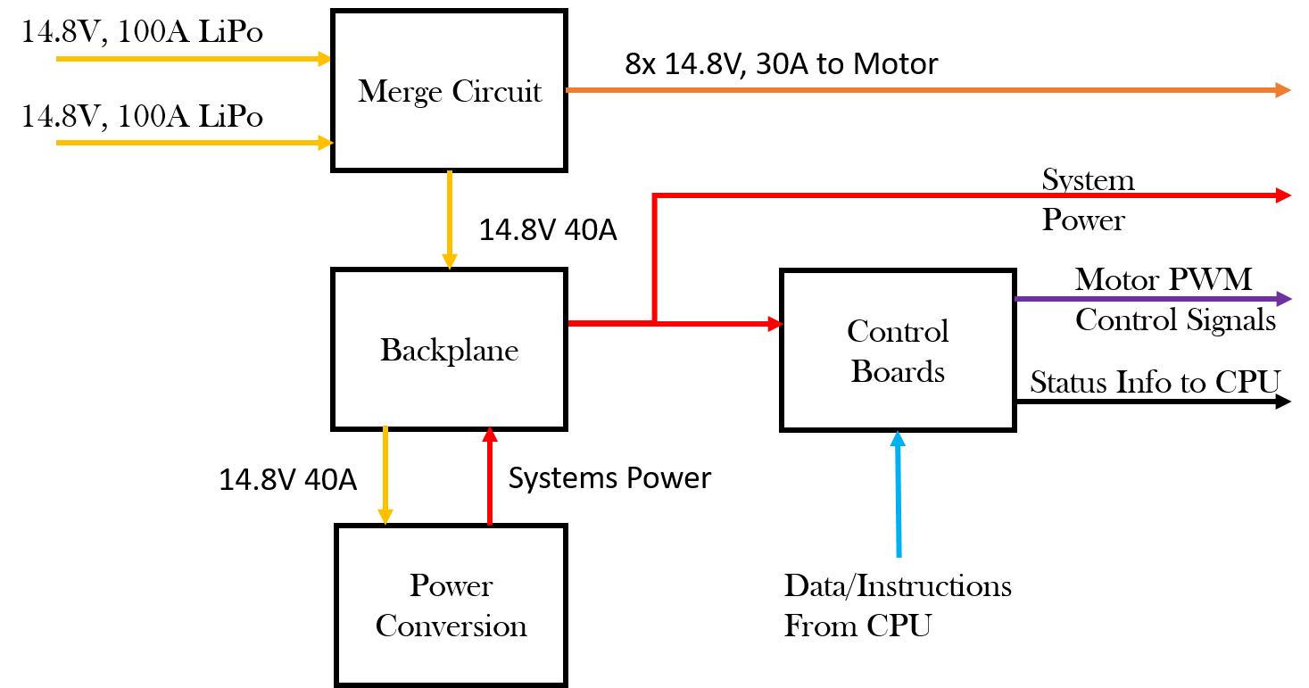

## Merge Circuit

The merge circuit safely merges together the two LiPo batteries in parallel, protecting the batteries from having their voltages separate to the degree where one batter may begin incidentally charging another.

## Backplane

The backplane facilitates power distribution throughout all the custom electronics. In addition it contains wire-to-board connectors that allow power to be distributed from

FD Level2 Merge Circuit.png

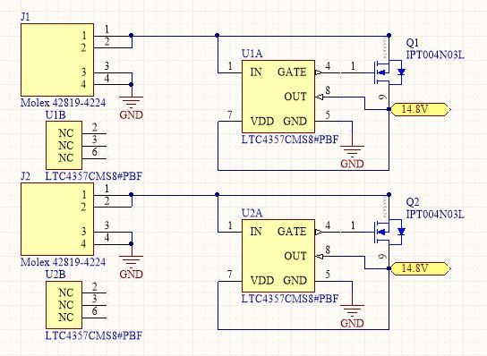

Power CDR.png

